EADS NA Defense Test & Services

Software Design Document

COM Port Bus
WCEM Driver – WcemCOM.dll

SDD-WcemCOM
Version 0.00
06/20/05

This document and the information contained herein are proprietary to EADS NA Defense and may not be disclosed in whole or in part to any parties without the expressed written consent of EADS NA Defense.

PAWS is a registered trademark of the TYX Corporation.

© EADS NA Defense Test & Services
1222 Lucas Ave. Suite 200
St. Louis MO 63103
phone (314) 727 1337
fax (314) 727 6750

Software Design Document

Version 0.00

History of changes
0: Initial Release

Change Table

Change | Date | Paragraph

1 Scope 5
1.1 Identification 5
1.2 System Overview 5
1.3 Document Overview 5
2 Reference Documents 5
3 System-Wide Design Overview 5
3.1 Assumptions and Dependencies 5
3.2 General Constraints 5
3.3 Goals and Guidelines 6
3.4 Safety and Security Considerations 6
3.5 Development Methods 6
4 System Architectural Design 6
4.1 System Components 7
4.2 Interface design 8
5 Detailed Design 9
5.1 Classification 9
5.2 ATLAS Modifier Definition 9
5.3 Port Names 10
5.4 COM Port Programming Specifications 10
5.4.1 Programming Resolution 10
5.4.2 Programming Accuracy 11
5.5 Processing 11
6 Notes 11
6.1 Atlas Examples 11
6.1.1 RS-232 Signal 11
6.1.2 RS-422 Signal 11
7 Requirements traceability 12
8 Appendix 12

Scope

Identification
The software configuration component WcemCOM.dll provides the software routines necessary to control the COM Port Bus.

System Overview
The PAWS system provides several methods of interfacing the compiled ATLAS object code with the test system instruments. The method used by this module is the Windows CIIL Emulation Module (WCEM). This mode of instrument control, the PAWS WRTS calls the WcemCOM.dll via ATLAS single action verb related functions. The WcemCOM.dll queries the WRTS for modifier values and other parameters and sends the necessary commands to the instrument.

Document Overview
The document defines the detailed software design for the PAWS WCEM driver for the COM. This document specifies the value ranges of all the ATLAS modifiers and modifier value ranges and how they are used to control the COM Port Bus.

Reference Documents
- ARC PAWS WCEM Software Development Style Guide (ARCSTL-DSG-000)
- Software Requirements Specification for Third Echelon Test Set DEFCOT&S-3536-SRS-001
- PERFORMANCE SPECIFICATION FOR THE THIRD ECHELON TEST SET (TETS) MARCORSYSCOM-PD-02-001 12/1/2003
- Computer Programming Manual (CPM) for the Third Echelon Test System (TETS) REV. E P/N 93006A0026
- IEEE std. 716-1989 C/ATLAS Test Language

System-Wide Design Overview
The PAWS development system provides the ability to code a test program in an extended / subset of the IEEE std. 716-1989 C/ATLAS Test Language. The PAWS development system provides the ability to modify the ATLAS subset with special nouns and modifiers (primarily analog) to meet special requirements.

Assumptions and Dependencies
The following assumptions and dependencies are made:

- The TETS ATLAS subset will contain the common ATLAS extensions found in most extended subsets of ATLAS (e.g. TRIG-SOURCE, TRIG-SLOPE, etc.)
- The TETS ATLAS subset will contain all required legacy ATLAS extensions that are not replaceable with the standard or common ATLAS extensions.
- The full instrument range will be implemented when they exceed the ranges in the system requirements specification.
- The full functionality of the instrument will be implemented to the extent possible where the ATLAS mapping can be defined. (Detailed below).

General Constraints
The sections below will detail which of the ATLAS modifiers are used and how they are used to control the COM.

Goals and Guidelines
- To the extent possible, map the ATLAS modifiers to instrument controls in a common sense manner.
- Implement the full range and functionality as can be supported by the extended subset of ATLAS.

Safety and Security Considerations
No safety or security considerations for this instrument.

Development Methods
As described in the “ARC PAWS WCEM Software Development Style Guide”

System Architectural Design
The PAWS WCEM driver is invoked on TPS load, TPS Unload, WRTS “Reset” / ATLAS “REMOVE, ALL”, and the derived “Single Action” ATLAS actions. The following diagram shows the major functions called from the WRTS through tables created by the WCEM Wizard in Wrapper.cpp. (See the “ARC PAWS WCEM Software Development Style Guide” for details). The essence of the WCEM driver is defined as a class CRS422. When multiple instruments (RS422s) are available in the station, an instance of the CRS422 class will be instantiated. Therefore, the member variables and methods need only control a single instrument.

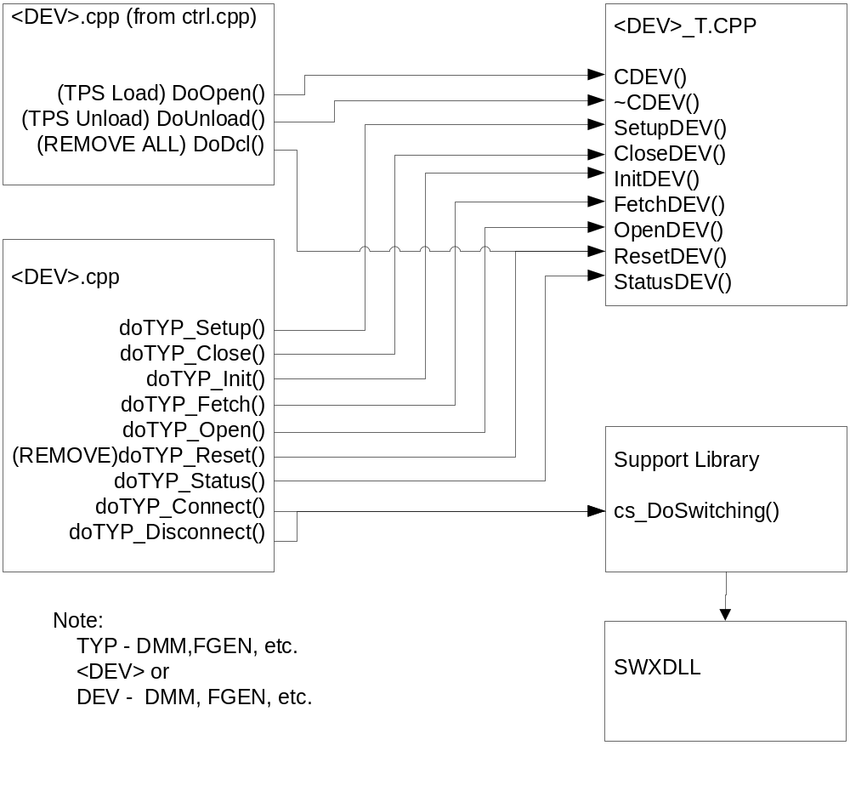
Figure 4.0 WCEM Function Relationships

System Components
The WCEM driver will consist of:

- A Microsoft Visual C++ project to build the WCEM
  - WCEM Wizard generated interface files
    - Wrapper.cpp
    - error.cpp
    - key.h
  - Configuration Information
  - COM.rc
  - resource.h
  - Updated Template File
    - COM.cpp
  - The programmer generated driver file COM_T.cpp

- A PAWS Developer’s Studio project file for the benchmark COM.PAW
  - An ATLAS program or programs to test the driver (Benchmark)
  - A Device Database static Description

Interface design

Function | Purpose
CRS422(bool sim, int dbglvl, int addr) | This function is used to initialize the instrument, obtain a handle from VISA or other controller software, and establish if the device is in simulation mode and / or debug.
~CRS422(void) | This function shuts down the instrument and releases the device handle.
SetupRS422(int fnc) | This function is the entry point for the setup action. The argument is the FNC number from the DeviceDB Static Description.
StatusRS422(void) | This function queries the instrument for status and reports any errors to the RTS via the error handling mechanisms
FetchRS422(int fnc) | This function is responsible for retrieving measured values from the instrument and returns them to the RTS via the fetch API in WCEM or other support libraries
InitiateRS422(int fnc) | This function controls the ATLAS INITIATE actions and is responsible for enabling or triggering a signal
ResetRS422(int fnc) | This function is responsible for resetting the instrument. The argument 0 will be reserved for a RESETALL action and shall reset the instrument regardless of the current state of the device. Arguments > 0 may use a state variable to determine if the device is currently reset.
CloseRS422(int fnc) | This function is responsible for the ATLAS CLOSE verb and shall close any internal relays within the instrument and will enable the output or input to the device.
OpenRS422(int fnc) | This function is responsible for the ATLAS OPEN verb and will disable the output or input of the instrument.

Detailed Design

Classification
This module is unclassified.

ATLAS Modifier Definition
The following table specifies the Nouns / Measured Characteristics / Modifiers used to control the Model:

Modifier | Dim | Value Range | Default | XML | Misc
ESTABLISH
BUS PROTOCOL |  |  |  |  | <Protocol Name>
SPEC, , BUS
RS232 | BUS |  | (type) STANDARD
RS422 | BUS |  | (type) STANDARD
STANDARD | N/A
PRIMARY | BUS

Modifier | Dim | Value Range | Default | XML | Misc
BUS-PARAMETER <bus-parameter>
PARITY |  | EVEN, ODD, NONE,  MARK | NONE
BIT-RATE | bits/sec |  |  |  | Maximum may vary due to cable length and line conditions.
WORD-LENGTH | Bits | 5 to 8 | 8
STOP-BITS | bits | 1, 1.5, 2 | 1
PROTOCOL PARAMETER <protocol parameter>
Not Legal
DEFINE EXCHANGE
EXCHANGE |  |  |  |  | <protocol name>
BUS MODE
TALKER-LISTENER | N/a
ALL-LISTENER | N/a
TALKER | <data store> |  | TEST-EQUIP
LISTENER | <data store> |  | UUT
DATA | <data store>
Modifier | Dim | Value Range | Default | XML | Misc
DO EXCHANGE
EXCHANGE |  |  |  |  | <protocol name>
TEST-EQUIP-MONITOR
DATA | <data store>
PROCEED | Sec | 0 to MAX-TIME | 0 seconds
WAIT | Sec | 0 to MAX-TIME | 0 seconds
MAX-TIME | Sec

Port Names
The Port Names in the table below provide the naming convention utilized in the Switch Data Base and Model for interface control and management along with the connection field mnemonics to be used by ATLAS programs.

CNX Field | Port Name | Instrument
HI | ICRS232-NTXD | COM2
LO | ICRS232-GND | COM2
TRUE | ICRS422-TXD-HI | COM1
COMPL | ICRS422-TXD-LO | COM1

COM Port Programming Specifications

Programming Resolution
TBD

Programming Accuracy
TBD

Processing
There are no special processing requirements other than normal ATLAS interpretation of the keywords.

Notes

Atlas Examples

RS-232 Signal
Example of programming the RS-232:

000001 BEGIN, ATLAS PROGRAM 'bustst' $
10 ESTABLISH, GLOBAL, BUS PROTOCOL 'rs232',
SPEC 'RS232',
STANDARD PRIMARY BUS,
CNX HI pin1 LO pin2 $
20 DEFINE, 'test', GLOBAL, EXCHANGE, PROTOCOL ‘rs232',
BUS-MODE TALKER-LISTENER,
TALKER 'UUT',
LISTENER TEST-EQUIP $
30 DECLARE, GLOBAL, VARIABLE,TMP',
'I' IS INTEGER;
'data-1',
'stat' IS STRING(16) OF BIT;
'list' IS ARRAY (1 THRU 32) OF STRING (16) OF BIT $

E001000 OUTPUT, C'Begin a RS-232 transaction' $
10 INPUT, INTO 'TMP' $

20 DO, EXCHANGE,
EXCHANGE 'test',
TEST-EQUIP-MONITOR DATA 'list' (1 THRU 32),
PROCEED,
MAX-TIME 2 SEC $
90 FINISH $

RS-422 Signal
Example of programming the RS-422:

000001 BEGIN, ATLAS PROGRAM 'bustst' $
10 ESTABLISH, GLOBAL, BUS PROTOCOL 'rs422',
SPEC 'RS422',
STANDARD PRIMARY BUS,
CNX TRUE pin1 COMPL pin2 $
20 DEFINE, 'test', GLOBAL, EXCHANGE, PROTOCOL ‘rs422',
BUS-MODE TALKER-LISTENER,
TALKER 'UUT',
LISTENER TEST-EQUIP $
30 DECLARE, GLOBAL, VARIABLE,TMP',
'I' IS INTEGER;
'data-1',
'stat' IS STRING(16) OF BIT;
'list' IS ARRAY (1 THRU 32) OF STRING (16) OF BIT $

E001000 OUTPUT, C'Begin a RS-422 transaction' $
10 INPUT, INTO 'TMP' $

20 DO, EXCHANGE,
EXCHANGE 'test',
TEST-EQUIP-MONITOR DATA 'list' (1 THRU 32),
PROCEED,
MAX-TIME 2 SEC $
90 FINISH $

Requirements traceability
This WCEM driver provides the requirements stated in Paragraph 3.4.16.8 of the PERFORMANCE SPECIFICATION FOR THE THIRD ECHELON TEST SET (TETS) MARCORSYSCOM-PD-02-001 12/1/2003

Appendix
None.

